Frequency Tables, Bar Charts, and Descriptive Statistics

Frequency distributions are one way in which data can be organized and displayed. They present the data in such a way that allows for quick conclusions to be drawn and basic comparisons to be made. They can also provide insight regarding the way in which the data are distributed, thus forming the basis for more advanced analyses. Descriptive statistics, including measures of central tendency and measures of variability, provide more in-depth insight to the data, and allow more detailed conclusions to be drawn.
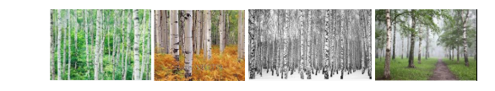

Summarizing and Describing Birch Tree Height
For this assignment, you will use the dataset provided to create frequency tables and bar charts, and calculate descriptive statistics. Copy and paste the SPSS output tables for these to a Word document, and then develop a summary in which you address the following:
- Summarize what the frequency tables and bar charts suggest about the data and the variables
- Make some general comparisons about the two locations (NY and MA) based on the frequency tables and bar charts
- Summarize what each measure of central tendency and measure of variability suggest about the data
- Use the measures of central tendency and measures of variability to make some comparisons between the two locations (NY and MA) based on the measures of central tendency and measures of variability
- Discuss which of these - frequency tables, bar charts, measures of central tendency, measures of variability - provide the best summary of the data, and explain why.
Dataset: Birch Tree Height (feet) in NY and MA https://www.fs.usda.gov/naspf/sites/default/files/publications/na-fr-02-97_how_to_grow_and_maintain_a_healthy_birch_tree_508c.pdf
Be sure to include supporting detail from the readings, as well as other scholarly sources. Please be sure to use college level writing, and to cite all sources used in APA style, including in-text citations and a reference list. If you are unfamiliar with APA style and/or need assistance with your writing, the following resources may be useful

